DIRECT ADVERTISING

Impact of direct advertising on market is different from corporate advertising. It has less cumulative effect, but affect acts immediately in the current period. Impact of direct advertising on sales does not depend on the type of product or market, the dependence is identical for all cells of the matrix of demand (3x3).

**Scenario 12C1 - Test 1 - All products, all markets (1 period)**

Rows on the chart represent products and markets. Vertical - the relative market change compared with previous period. Horizontal - the absolute value of direct advertising. Basic decision for test was direct advertising - 30. Chart displays the results from 30 test groups.

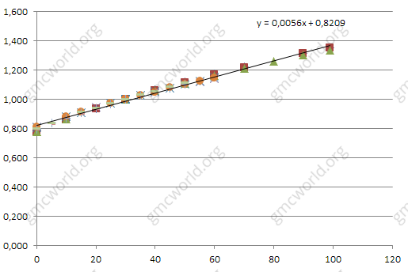

**Scenario 12C1 - Test 2 - Product 1, all markets (1 period)**

Points lie on trend, the difference between groups is insignificant, indicating that there is almost no affect on direct advertisement by competitors. Dependence directly proportional with coefficient 0.0056 - the relative change in sales % when direct advertising is changed by 1 unit.

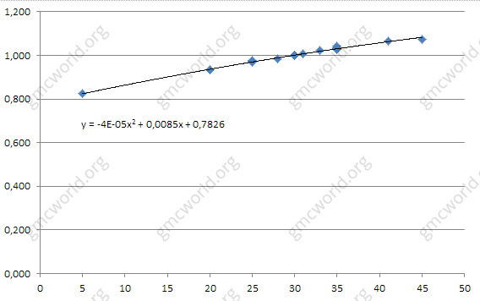

Direct advertising has a cumulative effect similar to corporate advertising, but less. Only 30% of direct advertising in previous period continues to act in the current period. It can be presented as if in the current period you add to your direct advertising plus 30% of investments from the previous period. Cumulative effect lasts for 1 or 2 periods.

**Scenario 12C1 - Test 3 - Product 1, all markets (2 period)**

Row 1 on the chart - relative market change in 1 period. Row 2 - relative market change in 2 period. You can see gradual strengthening effect for large values of direct advertising and smooth weakening effect for low values.

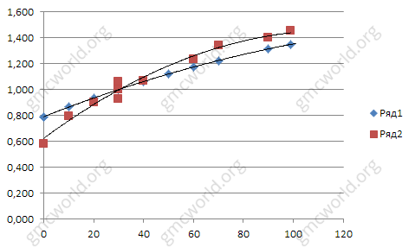

**Scenario 12C3 - Test 4 - Product 1, all markets (1 period)**

On scenario 12C3 in 1 period, the elasticity for product 1 is equal to 0.0055 and practically coincides with the coefficient 0.0056 on scenario 12C1. This slight difference indicates a lack of competition for influence of this factor.

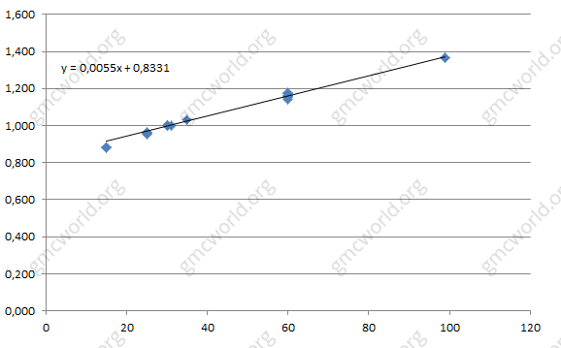

**Scenario 12C3 - Test 5 - Product 2, all markets (1 period)**

In the 1 period for product 2 not all points lie on trend, but data sample is small and not all tests were perfect, the elasticity is 0.0059

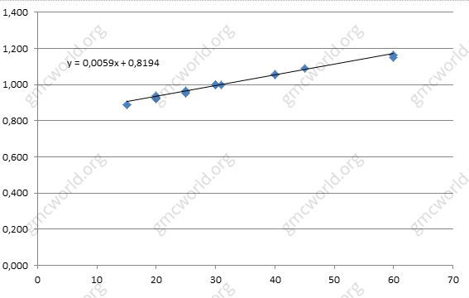

**Scenario 12C3 - Test 6 - Product 3, all markets (1 period)**

Similar test for the product 3, the range of direct advertising is 10-40.

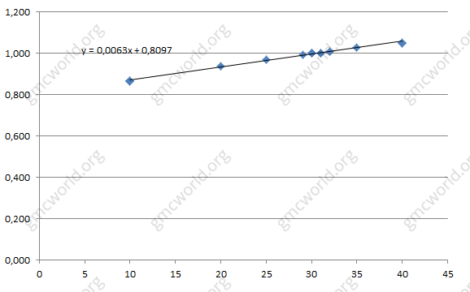

According to scenario 12C3 tests (6 groups), elasticity of each product is very close to the reference tests on scenario 12C1. Analysis was made with small range of variation of the direct advertising (10-60 and 10-40) for product 2 and product 3, so we can make a conclution that the elasticity of sales for all markets, products and both scenarios is 0.0056.

The optimal strategy is using direct advertising budget distribution according to the planned sales of each product. This will enable the best use of investments in marketing. More detailed information of direct advertising will be represented later in the typical strategy examples.

**Hints**

1．The residual effect is 30%.

2．Directly proportional dependence.

3．Effect is equal for all markets and products.

4．Small influence of competitors.

直接广告

 直接广告对市场的影响不同于企业广告。累积效应较小，但在当前时期立即受到影响。直接广告对销售的影响不取决于产品或市场的类型，对于需求矩阵的所有单元格，依赖性是相同的（3x3）。

**情景12C1 - 测试1 - 所有产品，所有市场（第1期）**

图表上的行代表产品和市场。 垂直－相对上一交易日的市场变化。 水平－直接广告的绝对价值。 测试的基本决策是直接广告－30。图表显示了30个测试组的结果。



**情景12C1 - 测试2 - 产品1，所有市场（第1期）**

积分在于趋势，群体之间的差异是微不足道的，表明竞争对手对直接广告几乎没有影响。 与系数成正比的依存关系0.0056 - 直接广告改变1个单位时销售额的相对变化。



直接广告具有类似于企业广告的累积效应，但较少。上一期只有30％的直接广告在本期继续采取行动。可以像现在这个时期一样，加上直接广告，再加上前一期的30％的投资。累积效应持续1或2个时期。

**情景12C1 - 测试3 - 产品1，所有市场（第2期）**

图表第1行－相对市场变化对于第1期。 第2行－相对市场变化对于第2期。 您可以看到逐渐强化的直接广告价值和低价值平滑弱化效应。



**情景12C3 - 测试4 - 产品1，所有市场（第1期）**

在12C3第1期的情景中，产品1的弹性等于0.0055，实际上与情景12C1的系数0.0056一致。 这个微小的差异表明这个因素的影响力不足。



**情景12C3 - 测试5 - 产品2，所有市场（第1期）**

在产品2的第1期，不是所有的点都在趋势上，而数据样本很小，并不是所有的测试都是完美的，弹性是0.0059



**情景12C3 - 测试6 - 产品3，所有市场（第1期）**

产品类似测试3，直销广告范围为10-40。



根据情景12C3测试（6组），每个产品的弹性非常接近场景12C1的参考测试。 对产品2和产品3的直接广告（10-60和10-40）的变化范围进行分析，所以我们可以确定所有市场，产品和两种情况下的销售弹性为0.0056。

最优策略是根据每个产品的计划销售量直接使用广告预算分配。 这将有助于最佳地利用市场营销投资。 直接广告的更详细信息将在以后的典型战略示例中进行表示。

**提示**

1．残留效应约为30%。

2．直接正比例依赖。

3．对所有市场和产品的效果是相同的。

4．竞争对手的影响力很小。